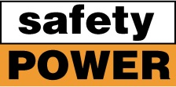 News for February 2014

ecoCUBE® SCR’s for CAT MWM 3MW and 4MW Natural Gas Cogen Facility
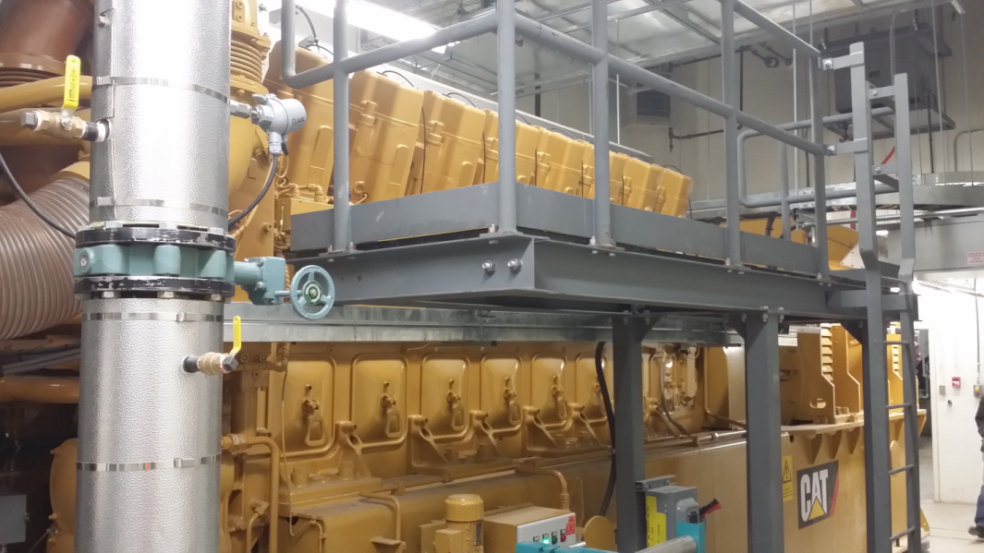
Safety Power’s ecoCUBE® SCR systems have been successfully commissioned on CAT CG260-12 (3 MW) and CAT CG260-16 (4MW) natural gas engines that are used in a cogeneration facility.
The ecoCUBE®’s are mounted above the engines in a separate room close to the heat recovery equipment. Temperature losses in the ecoCUBE® were extremely low to maximize the available energy for the downstream heat recovery equipment .
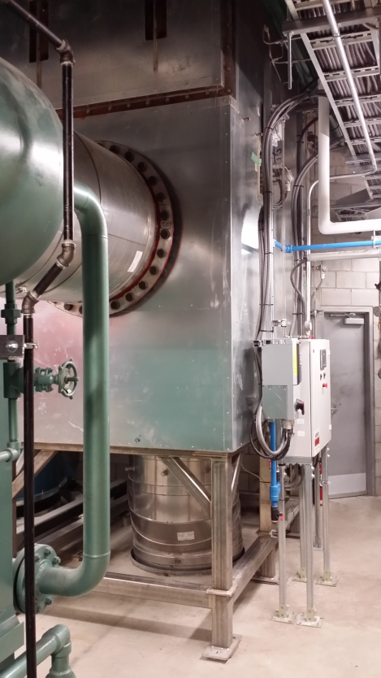
There are two separate sites for the engines. Each installation has 1 vertical ecoCUBE®’s. Space was a major constraint. As a result the ecoCUBE®’s are mounted in a a vertical orientation so that they take up less floor space. One of the ecoCUBE®’s, a 5 series, is being used with a CAT CG260-12 3MW gas natural gas engine. The other ecoCUBE®, an 8 series, is being used with a CAT CG260-16 4MW gas natural gas engine. The picture shows the series 8 vertical ecoCUBE®. Exhaust gas from the engine comes through the floor and exits into downstream heat recovery equipment. The ecoCUBE®’s are being used to provide NOx reduction using Safety Power’s advanced Selective Catalytic Reduction ( SCR ) technology.The ecoCube®control panel for the 8 series can be seen in the picture.

EPA Requirements for CAT Diesel Emergency Gensets – Webex February 25 1:00pm (EST)
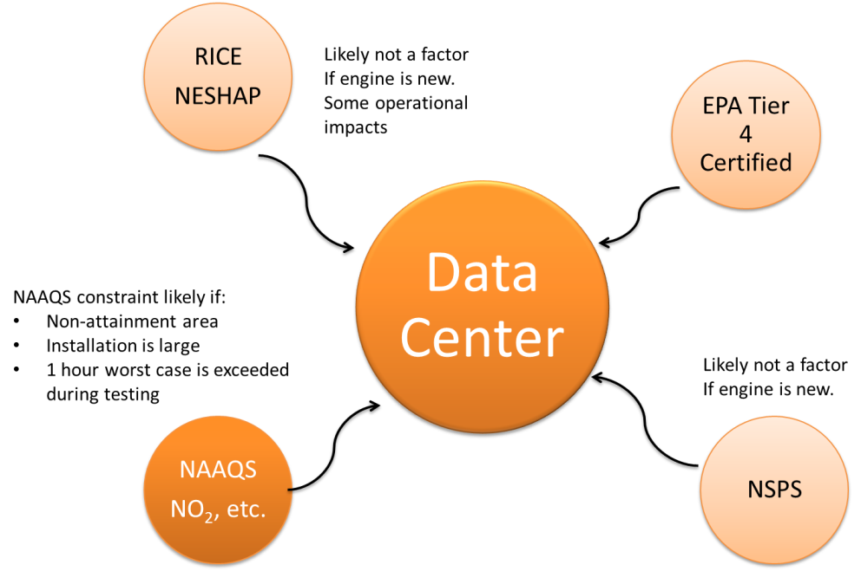
This session is ideally suited to CAT Electric Power Generation (EPG) dealers personnel who want to learn more about EPA requirements for diesel engines used in emergency and standby applications. Important EPA terminology such as RICE NESHAP, NAAQS, NSPS, Tier 4 etc are explained in a context that relates to emergency applications. In addition to covering the EPA requirements this session looks at the technologies – Diesel Oxidation Catalysts ( DOC ), Diesel Particular Filters ( DPF ) and Selective Catalytic Reduction ( SCR ) that address the regulatory requirements.

